St Mark’s Services
Dates for the Diary  6/11: Confirmations at St Alban’s at 1100 [there will be no 1130 service at St Mark’s]  20/11: Mthr Claire will celebrate her first mass at St Mark’s | Our website: Home | St Marks Church | Southend-on-Sea (stmarkschurchsouthend.org)  Our Facebook Page: (6) St Mark the Evangelist Southend | Facebook
St Alban’s Services
Home - St Albans (stalbanswestcliff.org.uk)
We pray for our local community in: [30th: Uniformed Organisations] 1st: Hamlet Rd, Princes St]
[2nd: Ashburnham Rd, Gordon Pl] [3rd: Gordon Rd, Napier Av] [4th: Elmer Av, Elmer Approach] [5th: Luker Rd, High St]
For those who are sick and in need:
David, Naomi, Eris, Tina, Kim, Glen & Megan, Lynda, Gail, Hannah, Betty, Kimmie, Rick, Margaret, John, Sonya, Richard, Renske, Lyn, Joanna and Jenson, John Henning, David Stanley, Adrian, Sammy, Pam, Jenny, Betty Crabtree, Sharon Corton, Elyza.
Prayers for all sick in hospitals and those who are caring for them.
Recently departed: Sandra Keenan, Mikey Cartwright and all who mourn.
All who have died with no-one to pray for them. All the casualities of the war in the Ukraine and in other countries.
In Memoriam: October
Pte I J Criswick KIA 26/10
Christine Isobel Lane 27/10
And all the saints in heaven!
Eternal Rest Grant unto them O Lord, and let light perpetual shine upon them. May they rest in peace, and rise in Glory+.
Asking for the prayers of the saints and Mary, we say:
Hail Mary Full of Grace the Lord is with thee
Blessed art thou among women, and blessed is the fruit of thy womb, Jesus. Holy Mary, Mother of God Pray for us sinners now, and at the hour of our death, Amen
Music @ St Mark’s
November Music
12 November: The Suspects

Parish of St Alban, Westcliff & St Mark, Southend

Sunday 30 October
All Saints Day

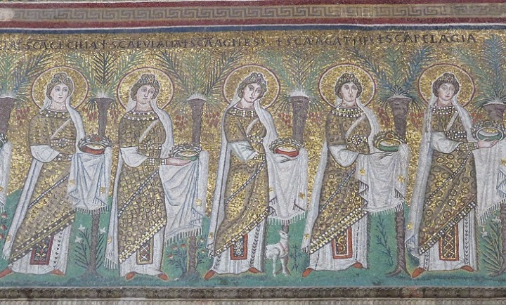

S. Apollinare Nuovo, Ravenna - side mosaic depicting a procession of female saints [6th century AD]

The Christian festival of All Saints Day comes from a conviction that there is a spiritual connection between those saints in Heaven and those on Earth. What is a saint? Well, a saint is one who has trusted in Christ alone for salvation. Therefore, as we believe the words of the creed that we say togther every Sunday, we are saints on earth! Our sacrifce for our faith often leads us to give up things that we might rather do than come to church; it might mean we give up our time and enegry in praying everyday. We always assume that saints are those who stand up to authorities and often die for their faith, but there are saints all around us! With love and blessings, Mother Cherry

Contact Details
Associate Priest: Mthr Cherry Sandover
revcherrysandover@gmail.com

Reader: Margaret Henning 01702 712564
margarethenning@outlook.com

Future Fundraising Events for your Diary
Deb and her band will be performing on 10/12
Mudlarks Choir on 12/12
Times to be confirmed

