27/9 Reflection

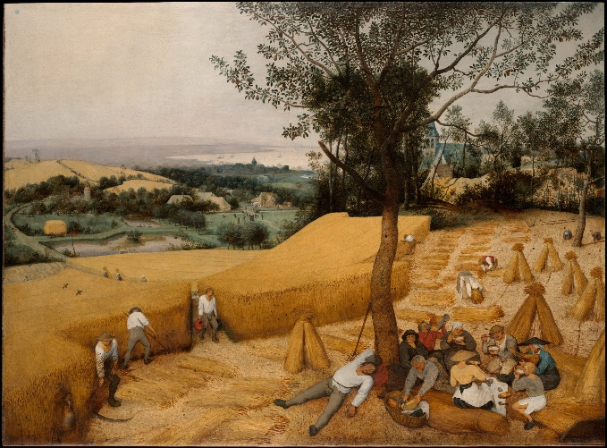
Pieter Brueghel the Elder, The Harvesters (1565) NY Met

This week’s art work was an easy choice as well as a rather predictable one! However, sometimes it is good to take a moment and revisit the ideas as well as the images we think we know well. As we prepare to give thanks to God for all the good things our planet so richly produces; we have to also be mindful that we are expected to share this marvellous generosity with all people, both those who inhabit the world now and those who are not yet born! Looking at this wonderful image of the land being harvested we know that we are looking at a bygone age when land used wisely produced enough for the smaller populations of the time. And even while some are still hard at work, others here look contented as they enjoy their midday feast together. Of course, this is a rather idyllic view of the 16th century class system; and the geometric orderliness of the painting helps to reinforce that feeling, as well as the sense that as they work the land they are somehow part of it. Therefore, all is as it should be. On the right side of the painting, in the background is the village church, reminding the viewer that all these natural gifts come from God, for which we should always be graciously thankful and not take their provision for granted. Many of us today live far removed from this type of living, but we have to remember that we are all still connected to those who sow and grow those things that we enjoy. Even if they are on the other side of the planet! Why not consider everything on your plate one day this week – and give thanks to those who made them possible. Whoever and wherever they are. Amen

